

American International University-Bangladesh (AIUB)  
**Department of Computer Science  
Faculty of Science &Technology (FST)  
Summer 21 22**

**<Internship Management System>**

Software Requirement Engineering

Sec:  **C**

Project submitted

By

*Rahman, Md Shohanur (19-39474-1)*

*Md. Shahidur Rahman Nayeem (18-38037-2)*

*Azim, Rifatul (19-39388-1)*

*Islam Md Tamidul (18-36232-1)*

1. **PROBLEM DOMAIN**
   1. **Background to the Problem**

Allocating internships to recent graduates or students in their final semester has grown to be a significant issue in Bangladesh. There are numerous websites with various job postings, but none specifically for interning students. Students have trouble securing internships after graduation. Sometimes students are unable to choose the best position and end up choosing the wrong job. Finding the ideal website for finding an internship might be challenging for recent graduates. Furthermore, the question of being paid or not constantly arises. Students frequently lack knowledge of available jobs and are unable to choose the best one. In some circumstances, students are unaware of the internship opportunities offered by the company or their targets. Instead of making the appropriate choice, individuals encounter difficulties as a result of poor decisions. There are also higher risks involved. Another issue that has to be brought up is that some students find it difficult to find a group for internship positions. People now aim to collect and document their activities in the era of social media. However, they frequently don't have a common platform to execute those tasks.

Managing an internship is quite time-consuming. The underlying causes of those issues are improper guidance and a lack of information prior to managing an internship or while studying. Another reason for those issues is dispersed planning. Due to the fact that following incorrect instructions can lead to the issues already indicated.

* 1. **Solution to the Problem**

Our goal is to create an application called "Internship Management System" that will solve the aforementioned issues. The software will help student or recent grads in selecting the ideal internship for their future. Students can choose their ideal job in that particular option with the help of the software. Students can use this software to identify the right companies and opportunities that are available. The program can help the students by delivering information about the intern based on the circumstances and conditions after they have chosen a job post. For the post, push notifications and alerts will be available in order for the students to learn as soon as possible about the position. The software will offer chat functionality so that individuals may communicate. Using the app, students will be able to store several posts. Typically, those issues arise for fresh graduates. The software will provide the solutions for all of them. This method is therefore especially suitable to address those issues. Of course, the solution can be implemented to get the desired business result. Therefore, the software will definitely have the chance to run its own business and earn money from it.

The software's goals are to lower the cost of recent graduates, save time, provide safety, and enable flexible communication environments. For the users, the software will function like an internship management system. The software's goal is to make the journey for recent graduates easy and hassle-free. The software's ultimate objective is to give students and recent graduates a tool that will save them money and time.

"Careerjet" is a piece of software that are now in existing. It offers suggestions for selecting internships and experienced positions alike. However, these methods fall well short of being able to address all of the aforementioned issues. The software we are going to create, which will offer all of the solutions to the aforementioned difficulties, will serve a different function than this one.

1. **SOLUTION DESCRIPTION**
   1. **System Features**

**Intern Seeker Application**

* Social Sign Up and Login:People can enter their first name, last name, phone number, email, age, and birthdate in this part for the chosen section. Users must be able to connect in to the system software using their assigned username and password. The system will randomly generate a verification code and send it to the user's email or phone number if the username and password have been entered incorrectly more than four times. For one hour, the system will prevent access to the user account if the verification code is used more than four times. A user can only sign in on two devices at once. The user has the option to sign up and log out of this software.

**Priority Level:** High  
**Precondition:** Valid user id and password

* Resume Management**:** In this section, the user must upload and amend their resume.

**Priority Level:** High

**Precondition:** User must be log in into system

* Profile Management: In this software, users of this software can update and alter the information they need.

**Priority Level:** High

**Precondition:** User must be log in into system

* Intern Job Search filter: The software will allow users to search an intern job based on location, salary, searched keywords etc.

**Priority Level:** High

**Precondition:** User must be log in into system

* Send Resume/Instant Apply: The software will allow users instantly apply for internships by supplying the necessary information.

**Priority Level:** High

**Precondition:** User must be log in into system

* In-App Communication: The software will allow user to text each other and communicate on the phone.

**Priority Level:** High

**Precondition:** User must be log in into system

* Savable Intern Jobs: The software will allow users to save multiple job post in section and can apply them later in remaining time.

**Priority Level:** High

**Precondition:** User must be log in into system

* Push notifications Intern Job Alerts: The software will send notification about the intern job posts which matches the profile and push alerts.

**Priority Level:** High

**Precondition:** User must be log in into system

**Recruiter Application**

* Sign Up/ Login via email: Each authenticatable user's email address, username, and password will be requested by the software for local storage on the server system. The server system then receives the user's usernames and passwords in plain text format and compares them to its internal database. The user is properly authenticated if the supplied credentials match.

**Priority Level:** High

**Precondition:** User must be log in into system

* Intern Job Editing: The software will allow recruiter to create, edit and delete job post.

**Priority Level:** High

**Precondition:** User must be log in into system

* Filter Resumes and Download: The software will allow user to select the resume that matches requirement and download them.

**Priority Level:** High

**Precondition:** User must be log in into system

* Send Internship Invites: The software will allow user to send invites to the seeker and invite them to view the descriptions.

**Priority Level:** High

**Precondition:** User must be log in into system

* Payment for Subscription Plans: The system will allow user to pay for the premium software feature.

**Priority Level:** High

**Precondition:** User must be log in into system

* Schedule interviews with Internship seekers: The software will allow users to schedule interview time with the seekers.

**Priority Level:** High

**Precondition:** User must be log in into system

* In-App Communication: The software will allow users to communicate with seeker through text message and phones.

**Priority Level:** High

**Precondition:** User must be log in into system

**Admin Panel**

* Manage Job Ads: The software will allow admin to approve/delete job ads posted by recruiters.

**Priority Level:** High

**Precondition:** User must be log in into system

* Manage Internship Candidate Profiles: The software will allow admin to view profiles of candidates and approve/delete use seeker request.

**Priority Level:** High

**Precondition:** User must be log in into system

* Recruiter Profile Management: The software will allow admin to view and edit information of recruiter accounts.

**Priority Level:** High

**Precondition:** User must be log in into system

* Invitations: The software will allow admin to view invitations and approve/delete the posts.

**Priority Level:** High

**Precondition:** User must be log in into system

* Internship Seeker Data Reports: The software will allow admin to view all available data and statistics of recruiters and seeker.

**Priority Level:** High

**Precondition:** User must be log in into system

* Reports for earnings: The system will allow admin to view the financial statements and the subscription rate of the recruiters.

**Priority Level:** High

**Precondition:** User must be log in into system

* 1. **UML Diagrams**

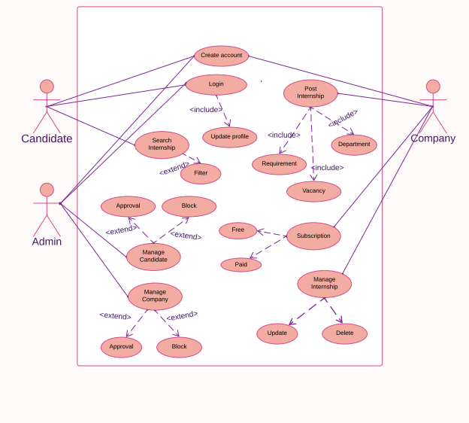

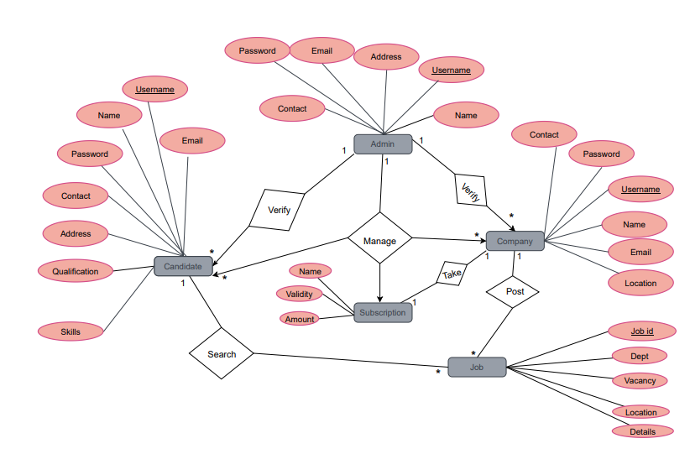

1. **Social Impact**

Nowadays, going for an internship has become very important as it ultimately increases the chances of finding a job after graduation and fits into the showcase effortlessly. Educational learning has objectives and interfaces to create effective access to showcases for their students. Through internships, educational institutions will facilitate the process of enlightening the students by studying the demands of advertising and making them aware of their skills and competencies. Companies/businesses provide sustainable capabilities and engagement opportunities for students. Internships will facilitate the process of finding gifts that fit the internal culture of the company/business organization/business and enhance the skills of the entity. It is common to offer internships to students as an opportunity to enhance academic learning and compete for their careers in companies/businesses. We've seen that businesses that use assistants come from a variety of industries. Businesses regularly use assistants and report satisfactory reviews on internship forms as well as various challenges such as supervision and/or assistant needs, assistant compensation, and more. Computerized mediums are used as a source to discover assistants, and a web-based internship entry is invited by businesses. Regardless, an in-person meeting may be a preferred strategy to meet with a principal. There are break-even trades with full-time and half-time assistant requirements, and trades require students to work in both the summer and winter seasons. Students appear to be interested in doing internships, and the current status of internship handles is generally at an average/fair completion level. There are different trends for assistant instruction, as well as different profitable special abilities, which are exceptionally important without speculative information. Finally, skills are crucial.

1. **Development Plan with Project Schedule**

To guarantee your assistants get profitable presentations to the distinctive ranges of your organization, consider creating an internship program plan populated with exercises for assistants to associate more profoundly with the company, construct abilities, and bond with one another. One of the keys to creating a compelling internship program plan is to begin early. It takes time to create a comprehensive plan and enlist the people and get the assets you would like. A sensible assignment time is four to six months so you may be prepared when your understudies arrive. Project Schedules somebody with an active plan, you know how effortlessly time can get absent from you. That said, it’s vital that whoever is overseeing your assistants (whether you or somebody else inside your organization) sets aside time each week or each other week, with each understudy to check in with them and grant them the consideration and offer assistance that they require. Sketching out these reliable check-ins in your internship program format will offer assistance to guarantee you and your assistants have normal facetime. In truth, this doesn’t apply to understudies — it’s a great thing to have all directors do with their coordinate reports because it makes a difference and makes a great company culture. These week-to-week or fortnightly check-ins should let you know how assistants are changing their positions. This is a great opportunity to ask them questions and welcome them all, as well as set a few wishes and observe their achievements. By creating this line of communication, you should trust assistants who respect you as a boss and value your time as well as your input. If a problem arises, you need to be comfortable with your subjects rather than hating a parcel of involvement.

1. **Marketing Plan**

A marketing plan is a roadmap to present our products to different audiences in the most effective way possible. The primary objective of a marketing plan is to institutionalize our techniques and strategies. This will keep us on schedule and enables to evaluate the success of our marketing. It is very important to develop a plan that will help us to increase the brand value and develop a corporate image for our software. The marketing team will be recruited based on their experience of the field work.

1. The first step in our marketing plan will be conduct research about our market. It will help us to make our marketing plan.

2. We will contact all universities that have internship programs and inform their students that they can find internships through our portal.

3. Engaged with direct corporate marketing approach for Recruiter.

4. Digital marketing for internship Seeker and Recruiter.

5. Organizing and conducting job fairs, seminars and many business exposes.

6. We will write effective & informative content then post it to educational websites.

7. Email marketing for internship Seeker and Recruiter.

8. Encourage the use of word of mouth publicly from our loyal and satisfied internship Seeker.

9. Advertised our business in relevant magazines, newspapers, and related Facebook group

1. **Cost and Profit Analysis**

This software cost and profit analysis is given bellow.

## Software Development Cost:

|  |  |  |  |
| --- | --- | --- | --- |
| Item Name | Hours | Bdt/ Hours | Total Cost |
| Architecture Development | 20 | 800 | 16000 |
| Admin Page & User | 120 | 1000 | 120000 |
| Individual object pages | 270 | 1000 | 270000 |
| User profile page | 15 | 1000 | 15000 |
| AWS development | 20 | 1200 | 24000 |
| Total Developer hours | 445 |  | 445,000 |
| Total QA hours | 60 | 500 | 30000 |
| Total Designer hours | 65 | 450 | 29250 |
| Total PM hours | 110 | 1000 | 110000 |
| Total Cost | 680 |  | 614,250 |

**Total Cost:**

|  |  |  |  |
| --- | --- | --- | --- |
| Number | Cost Description | Month | Year |
| 1 | Software Development | 614,250 | 614,250 |
| 2 | Promotional Cost | 125,000 | 1,500,000 |
| 3 | Software Maintenance | 125,000 | 1,500,000 |
| 4 | Office Rent | 50,000 | 600,000 |
| 5 | Employees Salary | 180,000 | 2,160,000 |
| 6 | Others Cost | 30,000 | 360,000 |
|  | Total Cost | 1,124,250 | 6,134,250 |

**Profit:**

### We will provide subscription plans for Recruiter companies. We will take payment of 2500 BDT per year from each Recruiter company. Our target is to sell our subscription plan to 3500 Recruiter companies within 1 year. Also we can generate revenue through admob.

2500*3500 = 8,750,000 BDT

Admob Revenue = 1,500,000 BDT Total Revenue = 10,250,000 BDT Total Cost = 6,134,250

Total Profit = 4,115,750 BDT

1. **Reference**

* Hameed, M., Abrar, M., Siddiq, A., Javeed, T. (2014), “MVC software design pattern in web application development“, International Journal of Scientific & Engineering Research, Vol. 5, No. 5, pp. 17-20.
* Hussain, S., Keung, J., Khan, A. A. (2017), “Software design patterns classification and selection using text categorization approach“, Applied Soft Computing, Vol. 58, pp. 225-244.
* https://www.nerdwallet.com/article/small-business/internship-programtemplate#schedule-consistent-check-ins